1. **What is the difference between data and information?**

|  |  |
| --- | --- |
| **Data** | **Information** |
| Raw facts | Produced by processing raw data to reveal its meaning |
| Have not yet been processed to reveal their meaning to the end user | Requires context |
| Building blocks of information | Bedrock of knowledge |
| Data management | Should be accurate, relevant, and timely to enable good decision making |
| Generation, storage, and retrieval of data |  |

1. **What is a database?**

* Shared, integrated computer structure that stores a collection of:
* End-user data – Raw Facts of interest to end user.
* **MetaData**: Data about data, which the end-user data are integrated and managed.
* Describe data characteristics and relationships

1. **What is a Database Management System (DBMS)?**

* A collection of programs that manages the database structure and controls access to the data stored in the database.
* A DBMS makes it possible for end users to create, read, update, and delete data in a database.

1. **What is the role of the DBMS?**

* Intermediary between the user and the database
* Enables data to be shared
* Presents the end user with an integrated view of the data
* Receives and translates application request not operations required to fulfill the requests
* Hides database’s internal complexity from the application programs and users.

1. **Figure 1.3 - The DBMS Manages the Interaction between the End User and the Database:**

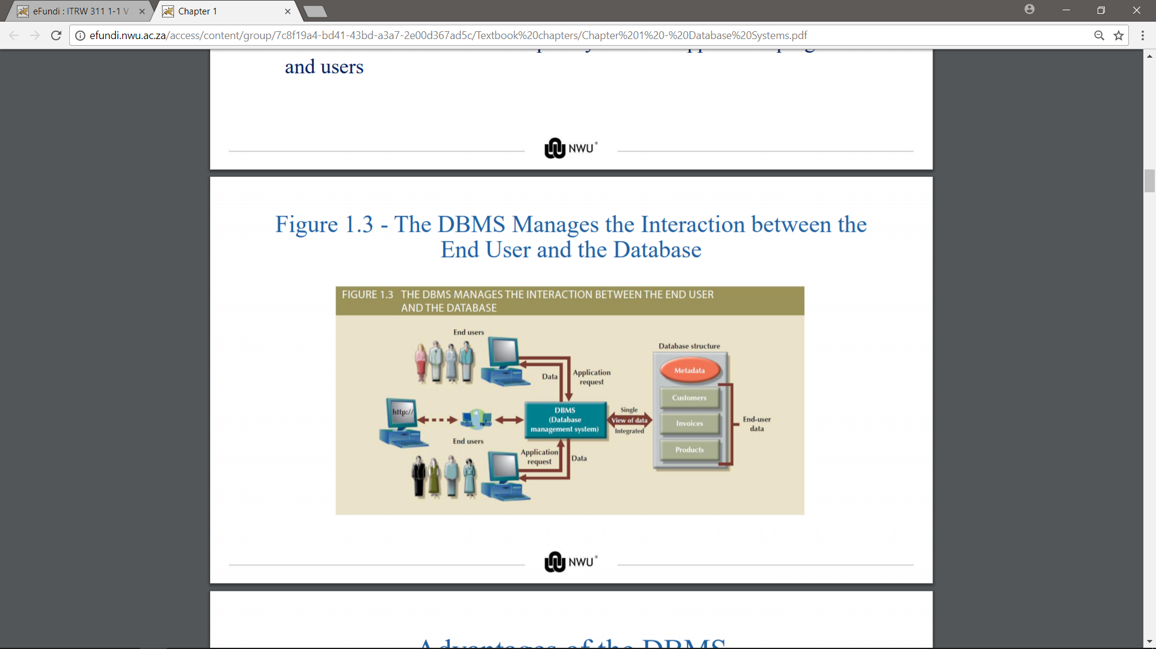

1. **What are the Advantages of the DBMS?**

* Better data integration and less data inconsistency .
* Data inconsistency: Different versions of the same data appear in different places
* Increased end-user productivity .
* Improved:
* Data sharing
* Data security
* Data access
* Decision making
* **Data quality**: Accuracy, validity, and timeliness of data.

1. **Name the different types of databases:**

* **Single-user database:** Supports one user at a time
* **Desktop database:** Runs on PC
* **Multiuser database:** Supports multiple users at the same time
* **Workgroup databases:** Supports a small number of users or a specific department
* **Enterprise database:** Supports many users across many departments
* **Centralized database:** Data is located at a single site
* **Distributed database:** Data is distributed across different sites
* **Cloud database:** Created and maintained using cloud data services that provide defined performance measures for the database
* **General-purpose databases:** Contains a wide variety of data used in multiple disciplines
* **Discipline-specific databases:** Contains data focused on specific subject areas
* **Operational database:** Designed to support a company’s day-to-day operations.
* **Analytical database:** Stores historical data and business metrics used exclusively for tactical or strategic decision making
* **Data warehouse:** Specialized database that stores data in a format optimized for decision support
* **Online analytical processing (OLAP)**
* Tools for retrieving, processing, and modeling data from the data warehouse
* **Business intelligence:** Describes a comprehensive approach to capture and processes business data to generate information that support decision making.
* **Unstructured data:** It exists in their original (raw) state.
* **Structured data:** It results from formatting unstructured data to facilitate storage, use and generation of information.
* Structure is applied based on type of processing to be performed
* **Semi-structured data:** Processed to some extent
* **Extensible Markup Language (XML)**
* Represents data elements in textual format

1. **What needs to be focused on with database design?**

Focuses on the design of the database structure that will be used to store and manage end-user data.

1. **What are the advantages of a well-designed database?**

* Facilitates data management
* Generates accurate and valuable information

1. **What are the disadvantage of a poorly designed database?**

Poorly designed database causes difficult-to-trace errors.

1. Look at the Evolution of file system data processing in slides!!
2. **What is data?**

Raw facts, such as telephone number, a birth date, a customer name, and a year-to-date(YTD), sales value. Data have little meaning unless they have been organized in some logical manner.

1. **What is a field?**

A character or group of characters that has a specific meaning. A field s used to define and store data.

1. **What is a Record?**

A logically connected set of one or more fields that describe a person, place, or thing.

1. **What is a file?**

A collection of related records.

1. **Figure 1.8 - A Simple File System:**

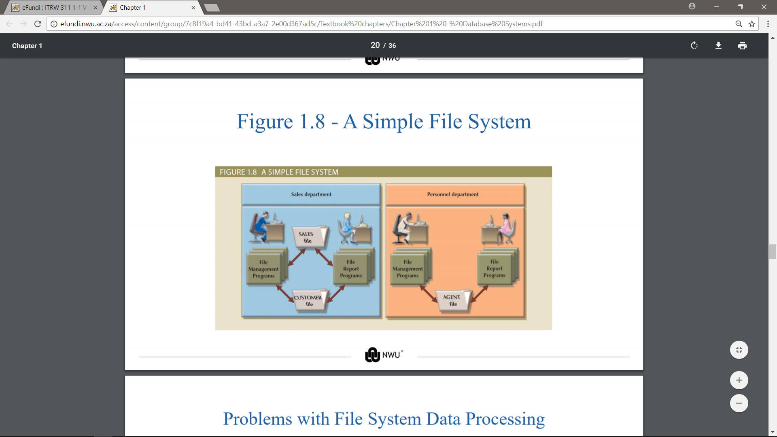

1. **Problems with File System Data Processing:**

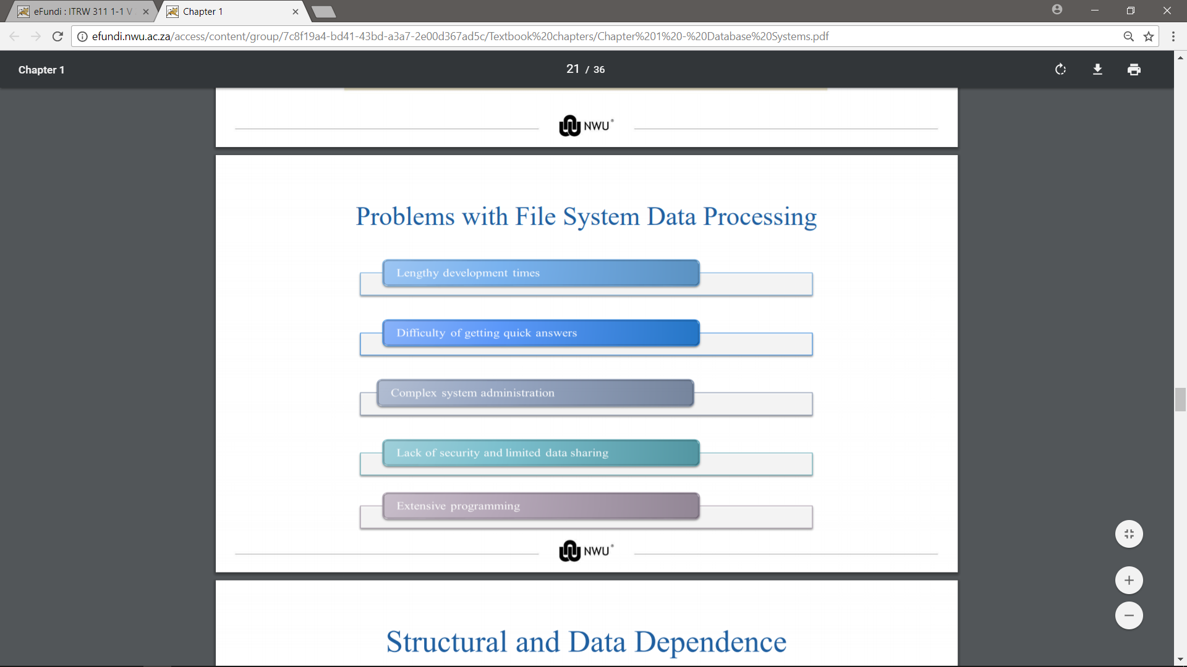

1. **What is Structural dependence?**

Access to a file is dependent on its own structure.

* All file system programs are modified to conform to a new file structure

1. **What is Structural independence?**

File structure is changed without affecting the application’s ability to access the data.

1. **What is Data dependence?**

Data access changes when data storage characteristics change.

1. **What is Data independence?**

Data storage characteristics is changed without affecting the program’s ability to access the data.

Practical significance of data dependence is difference between logical and physical form.at

1. **What is Data Redundancy?**

* Unnecessarily storing same data at different places.
* **Islands of information:** Scattered data locations
* Increases the probability of having different versions of the same data.

1. **What is the implications of data Redundancy?**

* Poor data security
* Data inconsistency
* Increased likelihood of data-entry errors when complex entries are made in different files
* **Data anomaly:** Develops when not all of the required changes in the redundant data are made successfully.

1. **Types of data Anomaly:**

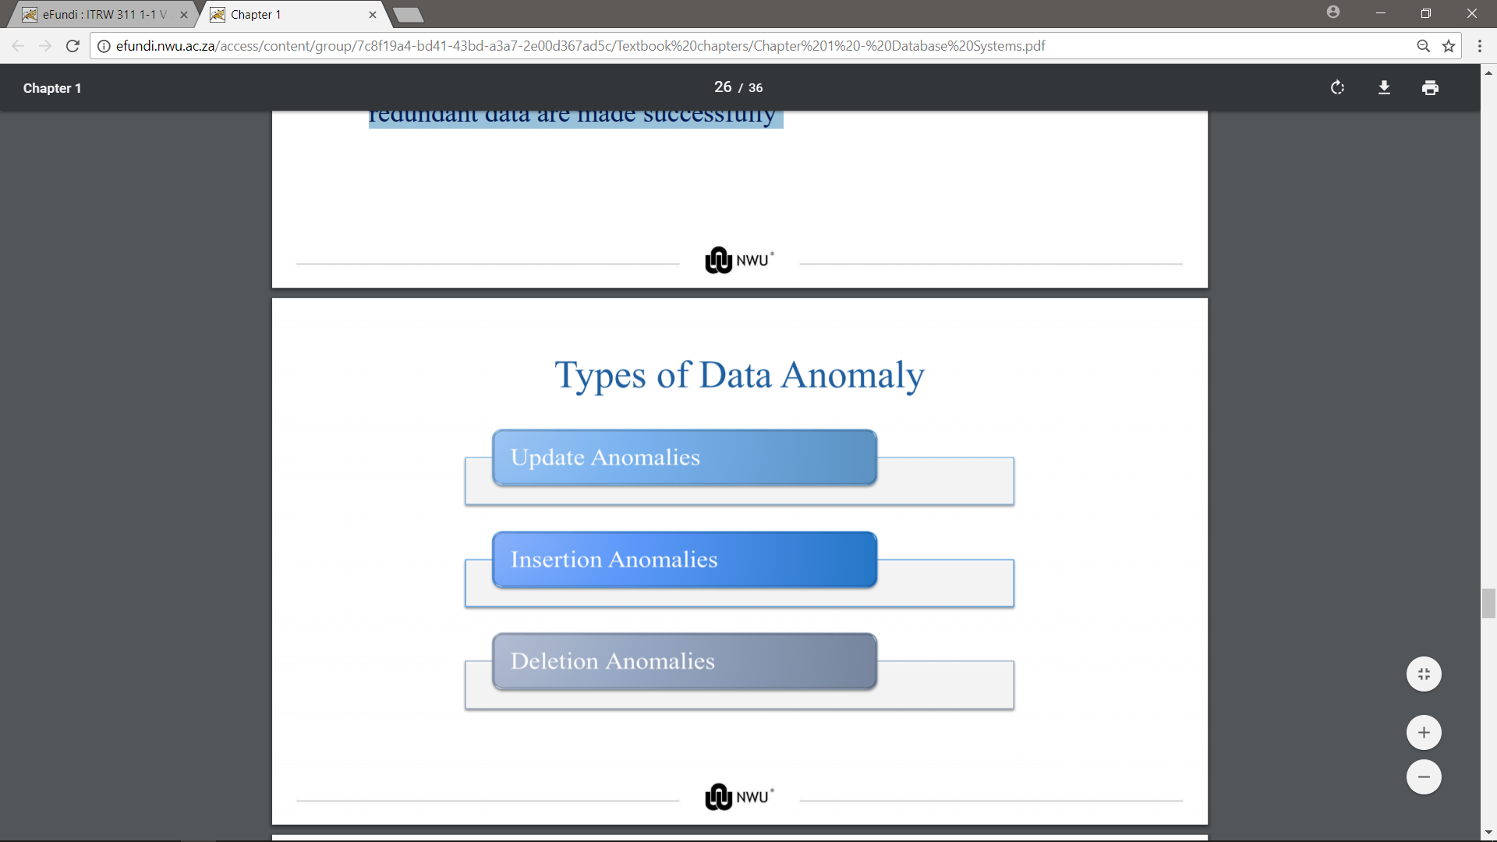

1. **Database Systems:**

* Logically related data stored in a single logical data repository
* Physically distributed among multiple storage facilities
* DBMS eliminates most of file system’s problems
* Current generation DBMS software:
* Stores data structures, relationships between structures, and access paths
* Defines, stores, and manages all access paths and components

1. **Figure 1.9 - Contrasting Database and File Systems:**

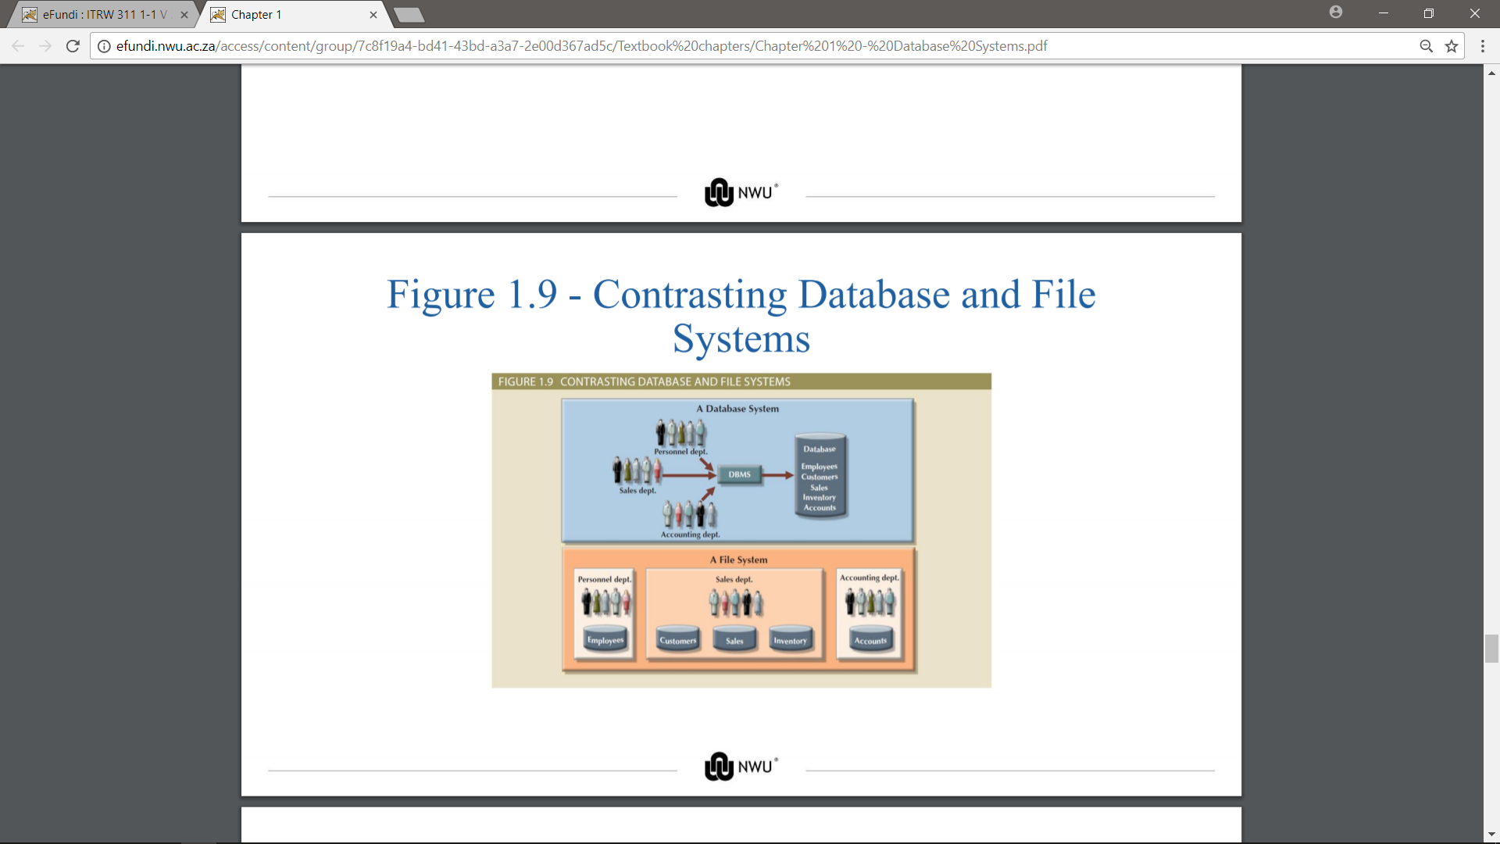

1. **Figure 1.10 - The Database System Environment:**

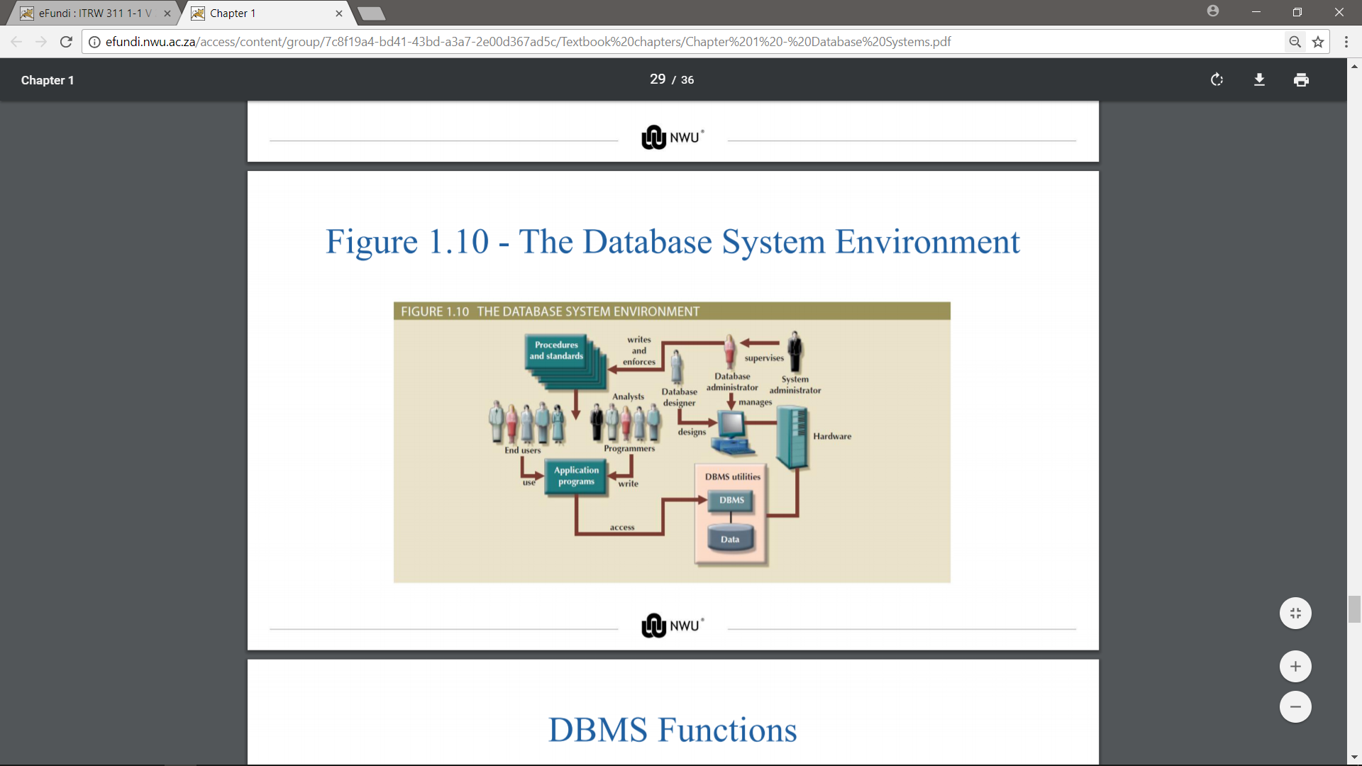

1. **Kyk na DBMS functions in slides.**
2. **What are the Disadvantages of database systems?**

* Increased cost
* Management complexity
* Maintaining currency
* Vendor dependence
* Frequent upgrade

1. **Table 1.3 - Database Career Opportunities:**

